# Implementation

For implementation we have use the JADE framework with which we have built a multi-agent system: Context Model Administering Agent (CMMA), Context Interpreting Agent (CIA), GUI Agent and Reinforcement Learning Agent (RLA). The RLA parses a world file description containing the xml description of the available sensors and ads that information to the context ontology representation, while the uses a pooling mechanism to gather sensor data at specific time intervals.

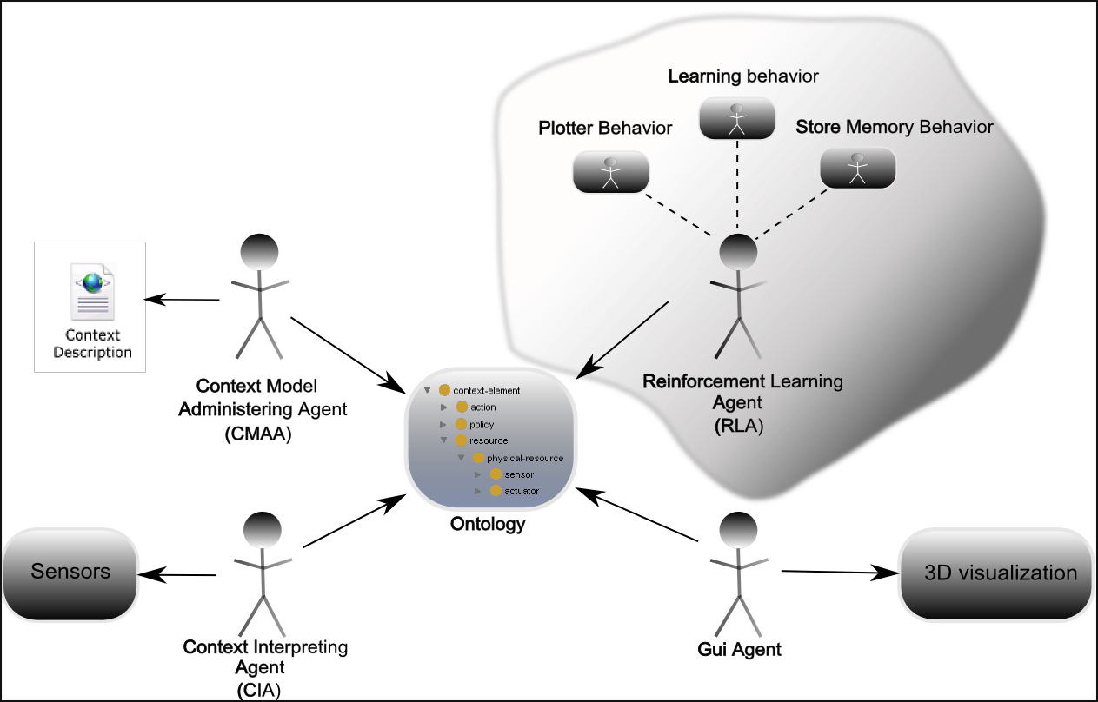

Figure 1 : Action Selection Framework Architecture

The actual action selection algorithm is implemented in the Learning Behavior attached to the RLA. The other two behaviors perform additional tasks like running time plot (Plotter Behavior) and file storage of what has been learned so far (Store Memory Behavior).

For test scenario we have chosen an environment having a computer, a camera with face recognition, a light source and an alarm. Each environment component has attached a sensor for monitoring its state and also one humidity and one temperature sensors have been added. There are three policies which our algorithm has to enforce: *light policy,* *face* *recognition policy* and *temperature and humidity* policy. The light policy specifies that the light should be on only if the room is not empty. The face recognition one specifies that if a professor is in the room the computer state must be on and if there is someone unknown in the room the alarm should go off. Last, the temperature and humidity policy enforces that the temperature should be between 18 and 23 degrees and the humidity between 20 and 30 %.

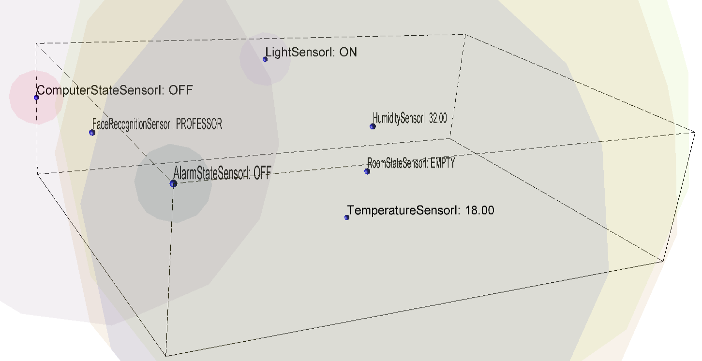

Figure 2: Test context